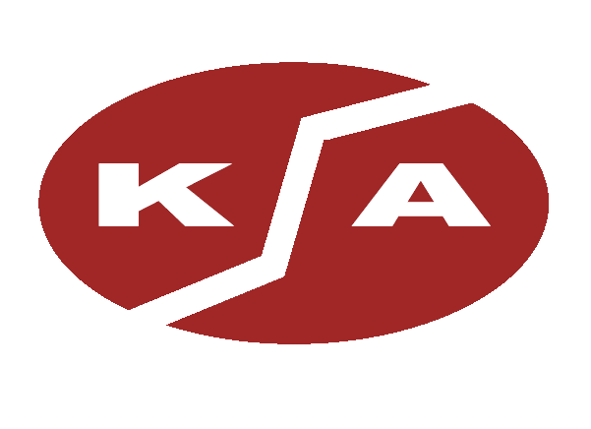 J. Koch Associates, Inc. Phone: (732) 388-8222 Fax: (732) 388-1920
P.O. Box 370, (1802 South Delaware Street), Paulsboro, New Jersey 08066
Website: www.jkoch.com e-mail: info@jkoch.com

Atwood & Morrill Co., Inc.  - Conventional, Bellows, Threaded, & Pilot Operated Relief Valves  - Chemical, Refining, Power, Cryogenic, & Sanitary Applications | 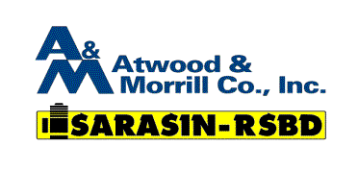
Controle Analytique  - PPM and PPB Nitrogen Analyzers  - Chromatographic Systems  - Sample Systems and Purifiers | 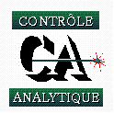

ITT Neo-Dyn
- Pressure, Differential, Temperature & Vacuum Switches
- Sanitary Pressure Switches
- Smart Pressure Switch (Transmitter)

Koso HAMMEL DAHL  - Globe and Angle Control Valves and Accessories  - Cryogenic and Severe Service Applications | 
Leser  - Self Draining Sanitary Relief Valves  - Flush, Inline, or Direct Mounting | 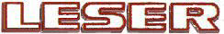
Remote Control  - Pneumatic (90º,180º, Multi-Turn)  - Electro-Hydraulic (90º)  - Electric (90º, Multi-Turn) | 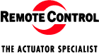
Spence Engineering  - Cast Iron & Bronze Safety Valves for Air, Gas, Liquid and Steam  - Section I & Section VIII Certified | 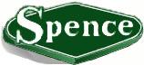
Thermo MeasureTech/Sensall Products  - Ultrasonic and Capacitance Level Sensors for Point and Continuous Measurement (liquid & dry) | Sensall
Tornado Technologies  - Conservation Vents  - In-Line & End of Line Detonation Arresters (Including Group B)  - Flame Arresters | 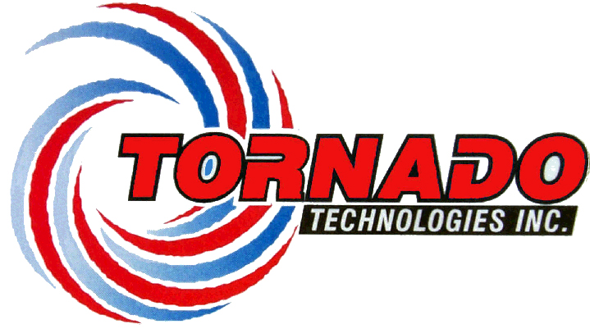
Tricentric  - High Performance Butterfly Valves  - Triple Offset, Bubble Tight, Zero Leakage, Fire Tested, Bidirectional Sealing | Tricentric ®
J. Koch Associates, Inc. Services  - National Board Certified Safety Relief Valve Facility  - Full Service Shop to Assemble, Repair & Certify Relief Valves  - Large In-House Inventory of New Valves and Replacement Parts | 